**Lab 6 – MAC/ARP**

**IT 520-A – Enterprise Infrastructure & Networks**

**Due Date: April 03rd, 2018**

**Michael Weiler**

Instructions:

• Clear your browser history, and visit: http://gaia.cs.umass.edu/wireshark-labs/HTTP-ethereal-lab-file3.html (your browser should display the US Bill of Rights)

• Using Wireshark, capture the packets. Remember to start, then visit webpage, and then stop.

• We are going to analyze Ethernet frames.

• Take a screenshot of your IP address (this is not part of your grade)

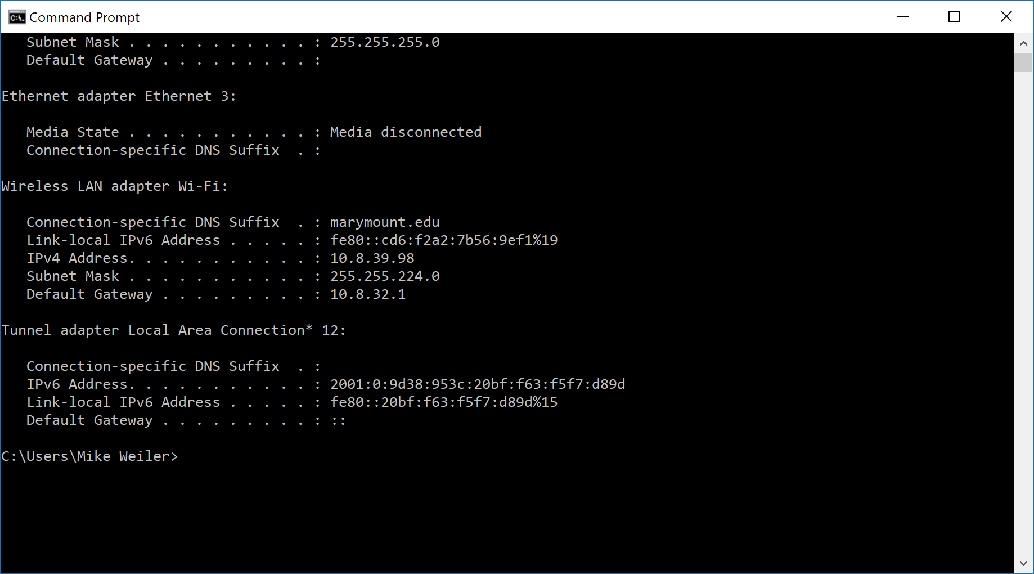

Questions:

1. What is the MAC address from your computer? b4:ae:2b:39:99:93

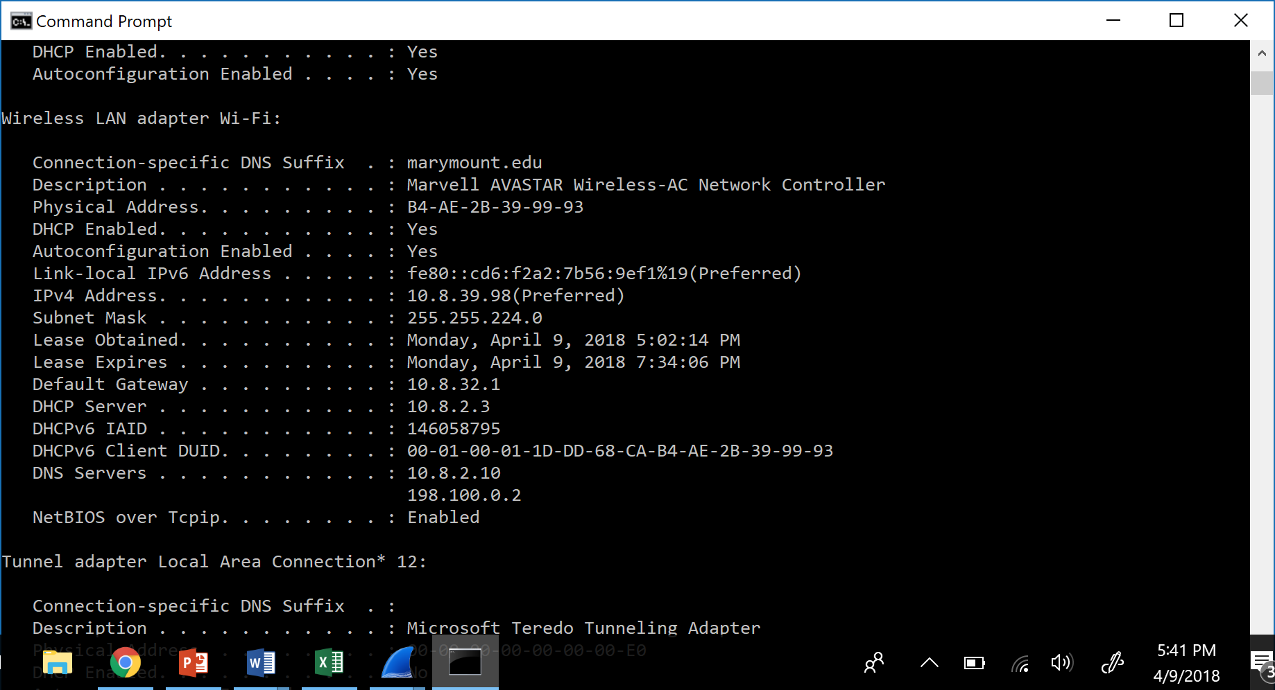

1. What is the destination MAC address? 00:2c:c8:59:ec:93

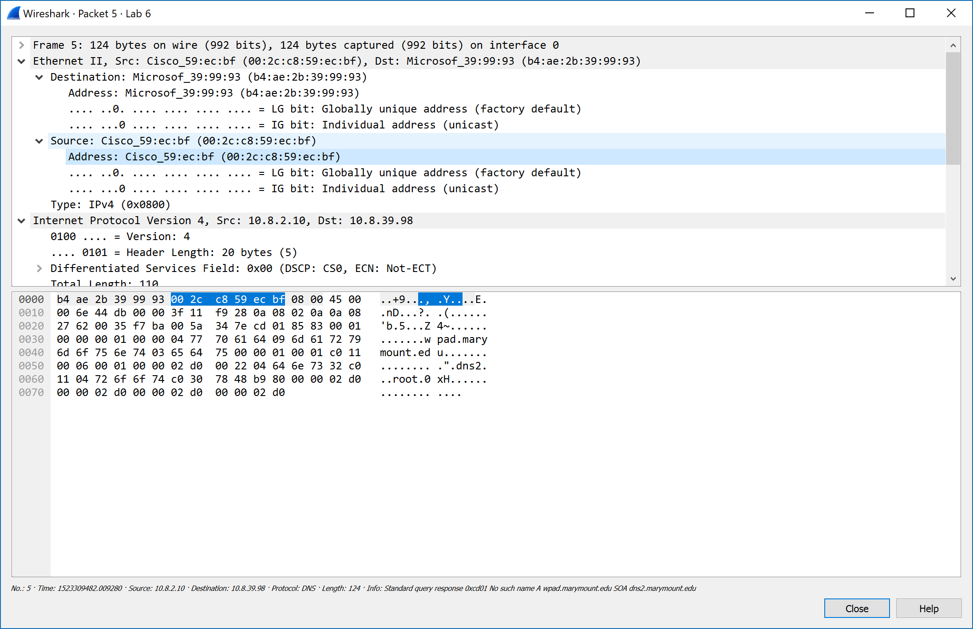

1. What device has the MAC address shown in the destination? Cisco



1. Explain the relationship between the destination MAC address and the destination IP address.

 If the destination host is not within the source host's network, the source host will send an ARP request  asking "who has the IP address of my default gateway?" and the default gateway will reply with its MAC address (which will be the destination MAC address).

1. Using the terminal (cmd in Windows, Terminal in mac), run a command to display your full ARP list table. (Find out what the command is, and print a full screen shot of your result.)

Command: C;\Users\Mike Weiler>arp -a

